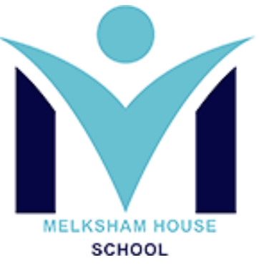

Melksham House SEND Information Report 2026-27.

Information about the Provision
Who can I contact regarding SEND provision at Melksham House
At Melksham House our culture is open, friendly and positive. Therefore, if you feel your Melksham House would be an appropriate placement for your child, we welcome you to organise a tour. Please contact the school office on info@melkshamhouse.uk who will arrange for you to meet with key staff if required. Consultations for places are made directly from Wiltshire Local Authority.

The SENCO oversees the SEND provision across Melksham House. If you require further information about our SEND offer please get in contact:
The School's SENCO is Stephanie Berry who can be contacted by phone through the school office or by email: sberry@melkshamhouse.uk

What type of SEND does our setting provide support for?

Melksham House, part of Brunel Education, has a planned admission number of 67 pupils in total aged 4-16 years old. Our primary cohort of 42 pupils have a Social and Emotional Mental Health (SEMH) profile. Our secondary cohort of 25 pupils have an Emotional Based School Avoidant (EBSA) profile and may also have a prifile of SEMH and/or a diagnosis of Autism / ADHD. We aspire to build a culture of Safety, Trust and Learning for neurodiverse young people through support, understanding and enablement. All pupils access the National Curriculum at either primary or secondary level.

There is a clear admissions policy and this is available for parents and carers to view via a link on the school website. We have pupils with a variety of SEND including:

- Autism, including those who have a demand avoidant profile.
- Social, Emotional and Mental Health (SEMH) needs, including those experiencing Emotionally Based School Avoidance (EBSA)
- ADHD
- Speech, Language and Communication needs
- Attachment Disorder

Breakdown of need September 2025/26:

SEMH – 100%
ASD/ASD Pathway - 69%
EBSA Profile – 68%
ADHD/ ADHD Pathway - 55%
SCLN - 43%

What specialist services and expertise are available or accessed by the setting?
Melksham House offers a number of specialist services provided by both the school and outside agencies.
What are “Outside agencies” and how can they help my child?
Outside agencies are professionals who work within the local authority, HCRG or the NHS and have specialist understanding in particular areas that will help us to meet your child’s needs.
The following outside agencies offer support to Melksham House:-
- Advisory Teacher for Speech, Language and Communication Needs
- Educational Psychologists
- Child Adolescent Mental Health Service (CAMHS)
- Learning Disabilities Nurse Team
- SEND Lead Workers
- Advisory service for hearing impairment
- Lead Healthcare Practitioners
- Parent Support Advisor (Wiltshire Parent Council)
- Community Outreach Workers
- Mentoring services
The following services are commissioned on a part time basis by the Melksham House:
- Play Therapist
- Talking Therapist
- Art Therapist
- Speech and Language Therapist
- Occupational Therapist
What training have the staff supporting pupils with SEND had or are having?
Staff within the setting are highly trained, and Melksham House invests heavily in staff development. Melksham House’s Continued Professional Development programme ensures that all staff access high quality training and development opportunities to ensure they have the specific SEND knowledge, skills and understanding to develop personalised SEND provision for our learners. At Melksham House, our CPD is underpinned by a commitment to continually developing staff knowledge, confidence and practice so that every adult is equipped to understand, support and enable our pupils to feel safe, succeed and thrive.

Melksham House has staff trained in the following areas:

- All Melksham House staff will complete a comprehensive Induction Program. All staff have already, or will be beginning to complete a Level 2 in Understanding Autism. There are staff on the Senior Leadership Team who hold Postgraduate qualifications in SEND.
- Postgraduate SENCo qualification- two members of SLT also hold this qualification.
- Sexualised Behaviour
- Emotionally Based School Avoidance (EBSA) training
- TEACCH – all teaching and learning staff
- Attention Autism
- Jane Considine Reading and Writing Training
- Social Stories training
- ELSA – qualified Emotional Literacy Support Assistants
- Communication – e.g. Makaton, Shape coding, communication aids and writing with symbols.
- De-escalation strategies and Positive Behaviour Management, including Team Teach
- Restorative Practice training
- Mental Health and Self Harm including all staff being trained to Level 2 in Mental Health First Aid.
- Attachment Disorder Training
- Emotion Coaching Training
- Child Protection – including PREVENT, FGM & Child Sexual Exploitation. A number of staff have completed Advanced Child Protection training, and Safer Recruitment training.
- Quality First Teaching for pupils with SEND
- First Aid
- Allergy Training
- Learning outside the classroom and forest schools, including Duke of Edinburgh Award.

SEND Offer

Melksham House’s Core offer
At Melksham House, we are committed to providing an inclusive and nurturing learning environment where all pupils can thrive. Our core offer is built upon the foundations of Quality First Teaching (QFT) and recognised best practice in SEND, ensuring that every pupil receives high-quality, tailored provision from the moment they enter Melksham House.
Quality First Teaching is central to our approach. It means that all Base Leaders:
- Have high expectations for every pupil
- Deliver well-structured, engaging lessons tailored to diverse learning needs
- Use adaptive teaching strategies and differentiated resources
- Create positive classroom environments that support independence and self-regulation
- Monitor progress closely and adjust teaching in response to individual needs
- Increasing a sense of belonging so that our pupils want to be part of something.
- Giving purpose to learning through an individualised, project-based curriculum so that what we do at Melksham House matters to each pupil.
- We allow success to develop a positive mindset - “I can do this”
- We offer them a safe adult who is calm, consistent, curious, cares, communicates and connects with them.
- We routinely share good news with parents and carers to build a positive culture for home to share with their child.
In addition, our core offer reflects best SEND practice, recognising the importance of understanding and meeting the unique profiles of SEND pupils. This includes:
- Structured, low-arousal learning environments that reduce sensory overload
- Visual supports and consistent routines to increase predictability
- Clear communication strategies, including the use of visual schedules, social stories, and alternative communication systems where appropriate
- A strong emphasis on emotional regulation, supported by access to calm spaces and individualised strategies
- Staff who are trained in a variety of SEND approaches, including autism awareness and trauma-informed approaches, and regularly update their knowledge to ensure current, evidence-based practice
We work in close partnership with families, external professionals, and – most importantly – the pupils themselves, to ensure that every pupil’s voice is heard and their needs are met with dignity and care.
Our aim is to remove barriers to learning, promote wellbeing and independence, and ensure that every pupil is empowered to achieve their full potential.
Trauma-Informed Practice at Melksham House

A At Melksham House, we are committed to building a culture of Safety, Trust and Learning, where everyone is encouraged to be Kind, Brave, Honest, Imaginative and Inclusive, and where every pupil feels a strong sense of belonging, enabling them to develop the resilience, confidence and skills they need now and in their futures. We believe that every child's unique experiences should help shape a nurturing, inclusive learning environment. With a significant number of our pupils having experienced trauma, trauma-informed practice is not an initiative—it is a commitment. It shapes how we teach, how we support, and how we grow together as a community. Through this approach, we lay the foundation for lasting positive change—ensuring that every child has the opportunity to develop feelings of safety and trust to enable them to thrive.
Our trauma-informed school culture begins with a clear understanding of what trauma-informed practice involves and the crucial mindset shifts it demands. This approach isn’t just about recognising the symptoms of trauma—it’s about transforming our school culture to promote safety, trust, and following our values of belonging, being kind, brave, honest, inclusive and imaginative for all members of our community. Our trauma informed approach at Melksham House is shaped and informed in collaboration with the Educational Psychology team and follows the Applied Trauma Responsive Classroom Model (below).
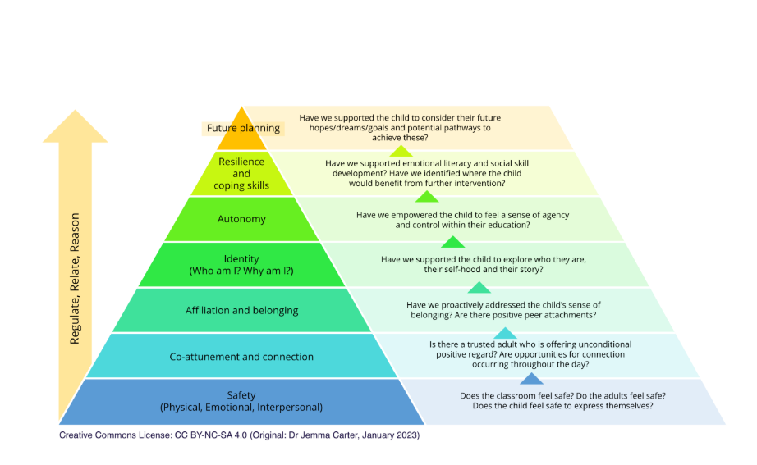

Trauma can profoundly affect how a pupil perceives the world, influencing their behaviour, relationships, and academic success. At Melksham House, we acknowledge that adverse childhood experiences can lead to challenges such as anxiety, chronic stress, withdrawal, or dysregulation. We recognise that these behaviours are a communication for our pupils, and strive to understand their root causes and respond with empathy and support.
We empower our staff to go beyond policy and embody trauma-informed care in their daily interactions. Through empathy, active listening, and consistent communication, our educators create spaces where pupils can thrive emotionally and academically. Staff, social workers, and administrators collaborate to build a robust support network that validates pupils’ experiences and builds their capacity for self-regulation and resilience.

What is Melksham House’s Emotionally Based School Avoidance strategy?
At Melksham House School, we understand that some of our pupils, particularly in our Secondary cohort, experience difficulties attending school due to emotional distress. Emotionally Based School Avoidance (EBSA) is a recognised area of need, and we are committed to supporting pupils and families through a compassionate, proactive, highly personalised and flexible approach.
Pupils may experience EBSA for a variety of reasons, including but not limited to:
- Anxiety disorders (including social anxiety or generalised anxiety)
- Autism or sensory processing difficulties, which can make the school environment overwhelming
- Separation anxiety, particularly in younger pupils
- Bullying or social difficulties with peers
- Academic pressures or fear of failure
- Mental health concerns, such as depression or low self-esteem
- Family-related issues, such as illness, bereavement, or instability at home
- Previous trauma or adverse childhood experiences (ACEs)
At Melksham House, we take a trauma-informed and person-centred approach to EBSA. Our staff are trained to recognise the multi-faceted profile of EBSA in pupils, and respond with empathy and understanding. We work closely with pupils, families, and external agencies to develop tailored support plans that promote emotional safety, resilience, and a positive reconnection with school.
Our EBSA support includes:
- Highly personalised learning packages that combine on-site and on-line learning to support pupils in accessing their learning in a way they feel comfortable with
- Early identification and monitoring of attendance and wellbeing
- Individualised strategies and reasonable adjustments to reduce anxiety
- Regular pastoral check-ins and access to emotional support
- Strong partnerships with families and relevant external services
By fostering a nurturing and inclusive environment, we aim to remove barriers to school attendance and help all pupils feel safe, supported, and ready to learn.
Staff at Melksham House have high expectations for our EBSA pupils, while regarding attendance, engagement and attainment. Staff are trained to support our pupils to achieve this by;
- Showing unconditional positive regard
- Believing in and validating our pupils
- Give timely, practical support when needed and desired.
- Review and reflect on all plans regularly and remember that things can change quickly.
- Ensuring their approach is child centred
- To work closely with the family.
- To be adaptable and do things differently
- To focus on the child’s strengths first
- Have a shared plan
- Taking small steps.

Assessment of need:
From the first term in the academic year or their first term at the Melksham House, staff will assess pupils not only in terms of their current academic level, but also in terms of where they are emotionally and socially. Planning will then reflect this, with an emphasis on enablement strategies to target progress and development based on pupil’s current presenting need.

Zones of Regulation
At Melksham House we us Zones of Regulation, which is a systematic, cognitive-behavioural approach that groups emotions and states of alertness into four coloured zones; Blue, Green, Yellow and Red. Each coloured zone represents a different level of emotion and physiological arousal, ranging from low to high. The Zones of Regulation approach helps our pupils here at Melksham House to recognise and manage their emotions, as well as understand how their feelings impact their behaviours.
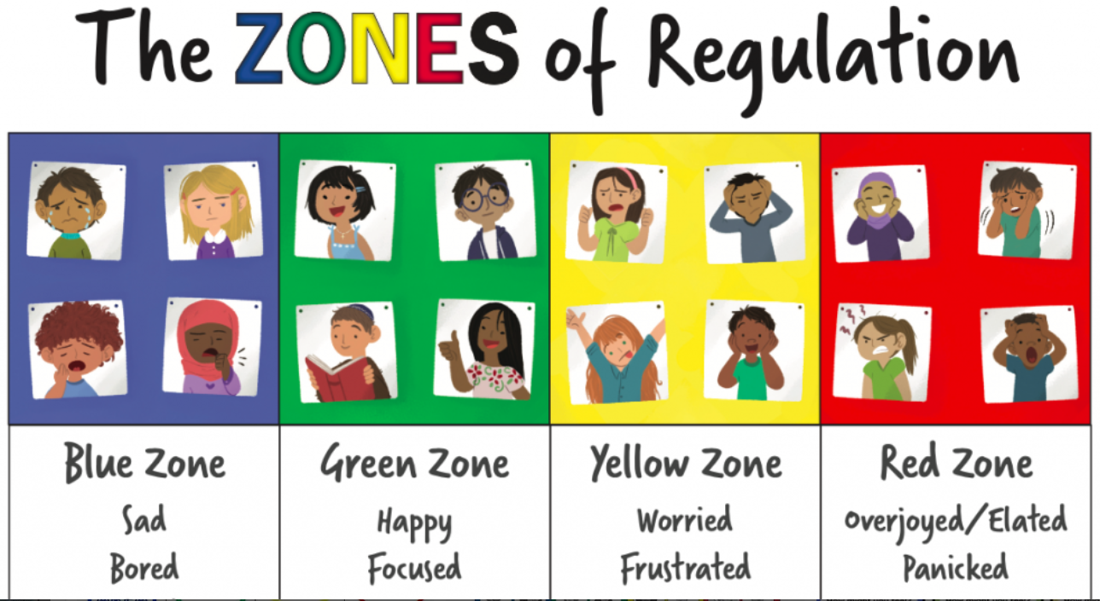
Curriculum

Our curriculum offer at Melksham House is distinctly built around the unique differences in the needs of our pupils between our Primary and Secondary pupils.

Primary Curriculum Offer (Years R-6)
Our EYFS and Primary provision is designed for pupils who are experiencing difficulties with social and emotional mental health needs, and who may need extra support in building relationships and a sense of safety. Primary bases learn through a full time on –site personalised curriculum, which is broken into small achievable chunks so that they might gain a sense of achievement and develop greater self-esteem. At Melksham House, our curriculum is designed to meet the individual needs, interests and aspirations of every pupil. Our Curriculum is delivered through an individualised, project-based approach, enabling pupils to engage with learning through meaningful topics and experiences that reflect their interests, strengths and areas for development. While each pupil’s project is personalised, learning is connected through a central ‘Big Question’, providing a shared focus that brings pupils together and creates opportunities for collaboration, discussion and a sense of belonging. Our curriculum remains rooted in the National Curriculum, with learning carefully adapted and personalised to ensure it is accessible, purposeful and relevant to each pupil. This approach supports pupils to develop academic knowledge alongside the wider skills, confidence and resilience they need to make progress and prepare for their future.
Our approach is grounded in relational practice, which fosters strong, supportive relationships between staff and pupils. This creates a nurturing and inclusive environment where children feel valued, understood, and empowered to take ownership of their learning. Through this ethos and a well-structured curriculum, we aim to develop not only academic success but also the personal and social skills essential for lifelong learning and wellbeing.
Secondary Curriculum
At Melksham House, our secondary pupils—all of whom have Emotionally Based School Avoidance (EBSA) profiles as well as SEMH needs—receive a full-time, high-quality education offer that is carefully tailored to meet their individual needs. Each pupil follows a highly bespoke timetable that blends on-site teaching with off-site structured online learning, providing the flexibility and support necessary to re-engage with education in a way that feels safe, accessible, and empowering.
Our secondary provision is organised around individual Base Rooms, providing pupils with a consistent, familiar and secure environment in which to learn. Rather than pupils moving between classrooms for different subjects, subject specialist teachers move between the Base Rooms. This approach minimises transitions throughout the school day, reducing anxiety and supporting pupils to develop a strong sense of Safety, Trust and Learning, as well as a strong sense of belonging within their learning environment.
Our secondary curriculum follows an individualised, project-based approach, with learning built around pupils’ interests, strengths, needs and aspirations. Each project is centred around a shared ‘Big Question’, which provides a common focus and opportunities for pupils to learn collaboratively while accessing learning at an appropriate level. The curriculum remains rooted in the National Curriculum and is flexible enough to support pupils to work towards a range of personalised outcomes and pathways. This may include GCSEs, Functional Skills qualifications or other appropriate accredited and non-accredited outcomes, depending on each pupil’s needs, abilities and future aspirations. This flexible approach enables pupils to access meaningful qualifications and prepare for their next steps in a way that is personalised, achievable and appropriate for them.
Our approach is underpinned by relational practice, fostering trust and connection between staff and pupils. This creates an inclusive environment where each pupil is supported to thrive both academically and personally.
Therapeutic provision
At Melksham House, we take a therapy-first approach to supporting our pupils, recognising that emotional wellbeing is the foundation for effective learning. Therapeutic input is not an add-on but is interwoven throughout our entire curriculum, shaping the way we plan, teach, and interact with pupils every day.
Our therapeutic provision is guided both by the specific requirements outlined in pupils’ Education, Health and Care Plans (EHCPs) and by the evolving needs identified by our skilled staff team. We offer a range of in-house interventions, including sensory circuits, Time to Talk, Brick Therapy, and other targeted support strategies tailored to individual needs.
All staff at Melksham House are trained in Level 2 Mental Health First Aid, ensuring that every adult in the school is equipped to support pupils’ emotional and psychological wellbeing. In addition to our internal provision, we also commission external services such as play therapy, counselling, and art therapy to provide a holistic and responsive therapeutic offer.
Through this integrated and compassionate approach, we aim to remove barriers to learning, build trust and resilience, and support every pupil to achieve both personal and academic success.
What support will there be for my child’s overall wellbeing?

Staff are well trained to enable them to meet the emotional needs of their pupils. Teachers, pastoral staff and care officers know their pupils well as individuals and work with pupils and families to support when any issues arise. Each lesson begins asking pupils to grade their emotional well-being using an emotional barometer that is appropriate for the pupils need, this is also referred to throughout the session to ensure anxieties are reduced and the pupil is ready for learning. Further personalised support is provided to pupils throughout lessons and social times to enable them to engage in learning and social opportunities successfully.

How will my child's progress be monitored?
At Melksham House, we monitor pupils’ progress both academically and relationally, recognising that positive relationships, emotional wellbeing and a sense of safety are fundamental to successful learning. Alongside formal assessment data, academic progress is tracked through 12-week outcomes, which are linked directly to each pupil’s EHCP outcomes and curriculum objectives. These are broken down into smaller, achievable steps to ensure that progress is meaningful, measurable and responsive to each pupil’s individual starting point and needs. Alongside this, Relational Support Plans are used as working documents to identify the individual support pupils require, including strategies and approaches that are known to be effective, as well as those that may not work well for them. These plans are reviewed and adapted as pupils develop and their needs change. This approach is highly collaborative, with pupils, families and staff contributing their knowledge, experiences and perspectives to ensure that support and learning remain personalised, consistent and focused on enabling each pupil to make progress.

Pupil Voice
At Melksham House, we are working towards the Rights Respecting Schools Award, which places a strong emphasis on pupils’ understanding of their rights and responsibilities as global citizens, as well as within their school and local communities. Pupil Voice is central to this approach, and pupils are taught that having their views heard and taken seriously is enshrined within their rights under the United Nations Convention on the Rights of the Child (UNCRC). We provide regular and meaningful opportunities for pupils to share their views, express their preferences and influence decisions about their learning and school experience. This includes contributing to their individual targets, Relational Support Plans and curriculum projects, as well as sharing their views through pupil voice activities, discussions, surveys and feedback opportunities. Staff actively seek to understand pupils’ perspectives and use this information to shape provision, ensuring that pupils are not simply heard, but that their views are valued and, wherever possible, acted upon. We recognise that pupils communicate in different ways and therefore provide appropriate adaptations and support to ensure that every pupil has the opportunity to have their voice heard.

Support for pupils and families

How will I know how well my child is doing and how will you help me to support my child’s learning and development?

Parents are contacted by phone, email and ClassDojo. As a minimum, this communication is weekly but can be daily, dependent on the pupil. On admission, your child’s Base Leader will discuss with parents/carers the preferred method of communication and the desired frequency of this. Base Leaders will use Dojo to post photos of your child’s learning or achievements for you to see.

Many of our families phone into school to pass on messages and we always try to ensure that staff return these calls within 24 hours. If school staff has any concerns they will contact the home setting straight away, likewise if there is good news to share, staff will call home too or send a private message on dojo.

There are 2 parent/carer meetings throughout the year in addition to a person-centred Annual Review where there will be an emphasis on future planning through a PATH meeting. In addition to these meetings, our looked after children (LAC) have personalised education plan (PEP) meetings, organised by the virtual school at Wiltshire Council. We report in writing to parents three times a year, with two succinct progress reports, focussing on academic progress and one full report at the end of the year.

What cultural backgrounds does the setting offer support to and how?

Difference, diversity and individuality are celebrated at Melksham House. We work hard to ensure that pupils have a local, national and global awareness are embedded in our culture through our Rights Respecting School Award and PSHE curriculum. Pupils are taught to respect others and their viewpoints and this is supported in personalised interventions. Melksham House’s key priority is safeguarding. As a result, there is a yearly staff development program that includes awareness around Child Protection, FGM, E-Safety, racism, Child Sexual Exploitation, PREVENT, homophobia/Xenophobia and self-awareness. This then equips staff to have conversations with pupils around these subjects as appropriate.

What support is there for Parents/Carers?

t Melksham House, we recognise that strong relationships with families and our wider community are essential to supporting positive outcomes for our pupils. Our Family and Community Support Worker plays an important role in strengthening these relationships and ensuring that families feel listened to, supported and included in their child’s educational journey. They provide a consistent point of contact for families, offering practical support, signposting to relevant services and helping families to access appropriate advice and resources. They work collaboratively with pupils, families and school staff to identify barriers, support positive communication and strengthen the connections between home, school and the wider community. Through this role, we aim to ensure that families feel valued, understood and empowered, and that the support provided around each pupil is joined-up, personalised and responsive to their individual needs.
There are also monthly parent coffee mornings to provide parental networking and support. We also offer termly therapeutically themed parent partnership coffee mornings which are led by our Therapy Team and Senior Leadership.

The SENCO signposts families and carers to support networks outside Melksham House including the SWAPP course.

We establish links with local support networks, such as Wiltshire Parent Carer Council, and share their belief that the best provision has high levels of engagement with parents and carers. Our commitment to fostering these links is part of an ongoing partnership to drive excellence for children and young people with special educational needs and disabilities.

What additional activities outside the classroom are available?

Staff make excellent use of the local amenities. There are almost daily opportunities for pupils to explore the outside environment. Additional activities include (but are not limited to):
- Forest School
- Community Campus – Sports hall, swimming pool, gym, library
- Learning Outside the Classroom curriculum, including Duke of Edinburgh Award from Y9 onwards if appropriate to the needs and interests of the pupils.
- Educational trips and visits linked to projects
- Visitors coming into school

Transition

At Melksham House, we recognise that transitions—whether into, within, or beyond our setting—are critical moments in a pupil’s educational journey. Our transition offer follows a clearly tiered, highly bespoke and flexible approach, designed to respond to the individual needs of each pupil with care and sensitivity.
Every pupil is supported with a personalised transition Padlet, which enables timely, two-way communication between school and home. This secure platform allows staff to share videos, photos, key information, and updates in a way that helps families feel involved and reassured, while also offering them the opportunity to share questions, insights, or concerns directly with staff.
Transition packages may include home visits, gradual introductions to school, and phased visits when pupils feel comfortable. Our approach is paced to suit each child, and we prioritise building trusting relationships before any major changes are made.
Staff at Melksham House receive training to help them respond to transition needs with empathy, patience, and flexibility, ensuring a consistent and supportive experience for all.
We also provide comprehensive transition support for pupils moving on from Melksham House—whether to another specialist setting, a mainstream school, or into post-16 pathways such as further education, training, or employment. This may include supported visits, collaborative planning with receiving settings, tailored transition resources, and multi-agency involvement to ensure continuity of care and support.
Our goal is to ensure that all transitions are positive, well-planned, and rooted in the individual strengths and needs of each pupil.

Further information

Can my child’s special dietary requirements be accommodated and how?

Our school lunches are provided by FW Catering, using fresh ingredients and, where possible, locally sourced produce. We recognise that some pupils have allergies, intolerances or other special dietary requirements and work closely with pupils, parents and carers to ensure these needs are understood and appropriately managed. Where a pupil has a diagnosed allergy, this is managed in line with our whole-school allergy safety arrangements and Individual Healthcare Plan, where appropriate, with relevant information shared with catering staff to support safe food preparation and service. This includes consideration of allergen avoidance and the prevention of cross-contamination.
Our menu is available via a link on Arbor, with a vegetarian option available each day. Pupils may also bring a packed lunch from home where this is their preferred or agreed option. We recognise that some pupils may require individualised arrangements around food and will work collaboratively with families to ensure that these are safe, inclusive and appropriate to the pupil’s needs. Our approach reflects the requirements of Benedict’s Law and the Department for Education’s statutory guidance on allergy safety in schools, which places a strong emphasis on whole-school allergy awareness, effective communication, individual planning and emergency preparedness.

How accessible is the school setting?

We are working hard to make Melksham House as accessible as possible. We have a clear plan to improve accessibility. All classrooms are accessible, with a lift helping to provide access where needed.

What type of and how many complaints did you receive last year and how were they resolved?

Complaints are dealt with following Brunel Education’s Complaints Policy, which can be found on the website. All complaints at Melksham House are dealt with seriously and treated on an individual basis.

Further Information:
The Wiltshire Local offer

https://www.wiltshirelocaloffer.org.uk/

The Wiltshire Parent Carer Council

https://www.wiltshireparentcarercouncil.co.uk/en/Home_Page

The Wiltshire Autism Information Pack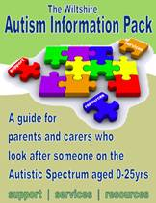
https://www.wiltshireparentcarercouncil.co.uk/images/1/1f/Autism_Pack_with_links.pdf

The National Autistic Society:
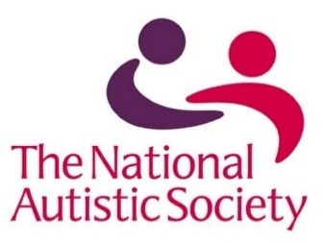
http://www.autism.org.uk/

